EXPERIMENT 1: Data Selection using Pandas

Aim:
To perform the given experiment using Python as per the lab manual.
To understand the concept and obtain the required output.
Algorithm:
1. Start the program.
2. Import the required libraries.
3. Load or define the given input data.
4. Apply the required operation as per the experiment.
5. Process the data using suitable functions.
6. Verify the intermediate output if required.
7. Display the final output.
8. Stop the program.
Program & Output :
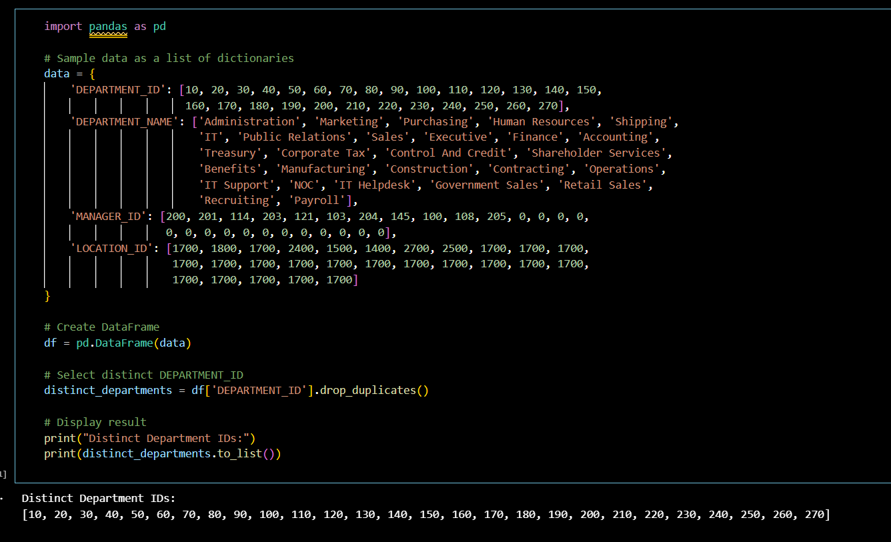
Result:
The experiment was executed successfully.
EXPERIMENT 2: Multiple Job Employees
Aim:
To perform the given experiment using Python as per the lab manual.
To understand the concept and obtain the required output.
Algorithm:
1. Start the program.
2. Import the required libraries.
3. Load or define the given input data.
4. Apply the required operation as per the experiment.
5. Process the data using suitable functions.
6. Verify the intermediate output if required.
7. Display the final output.
8. Stop the program.
Output & Result:
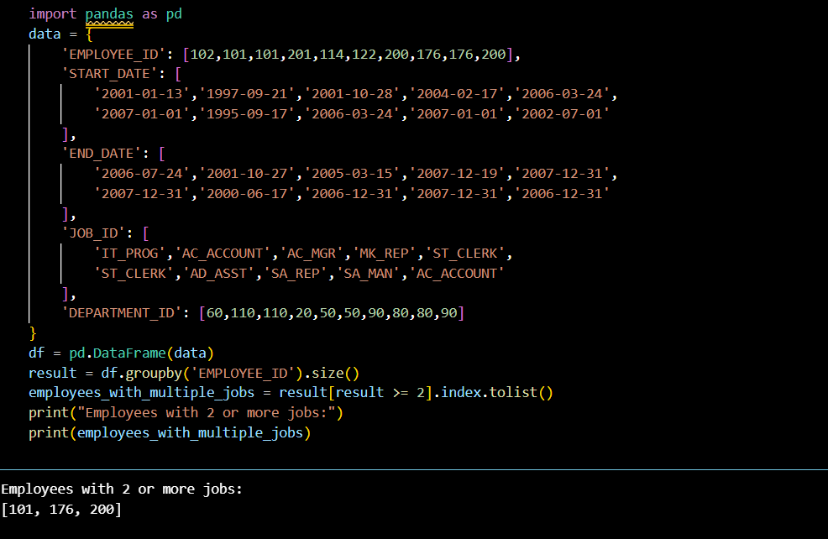
Result:
The experiment was executed successfully.
EXPERIMENT 3: Sorting Job Details
Aim:
To perform the given experiment using Python as per the lab manual.
To understand the concept and obtain the required output.
Algorithm:
1. Start the program.
2. Import the required libraries.
3. Load or define the given input data.
4. Apply the required operation as per the experiment.
5. Process the data using suitable functions.
6. Verify the intermediate output if required.
7. Display the final output.
8. Stop the program.
Output & Code
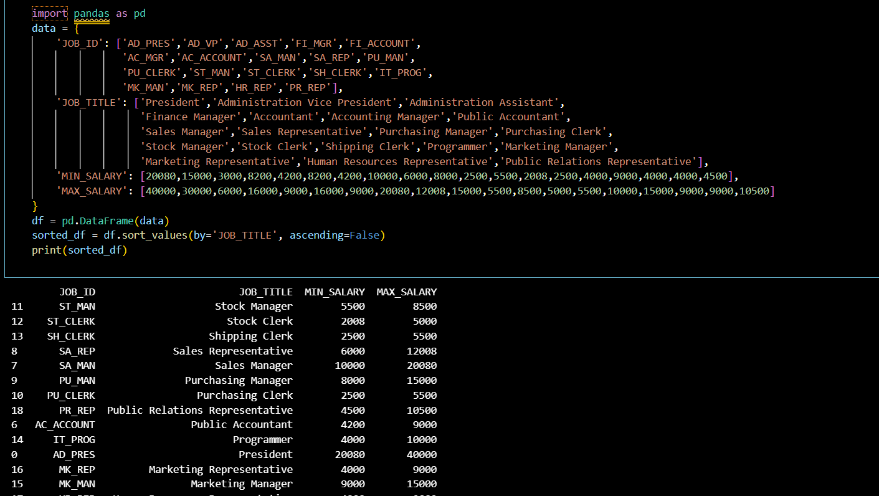 Result: The experiment was executed successfully

EXPERIMENT 4: Line Plot of Stock Prices
Aim:
To perform the given experiment using Python as per the lab manual.
To understand the concept and obtain the required output.
Algorithm:
1. Start the program.
2. Import the required libraries.
3. Load or define the given input data.
4. Apply the required operation as per the experiment.
5. Process the data using suitable functions.
6. Verify the intermediate output if required.
7. Display the final output.
8. Stop the program.
Output & Code:
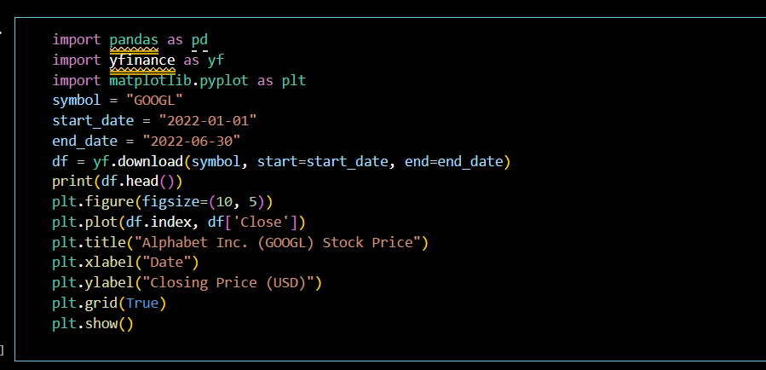
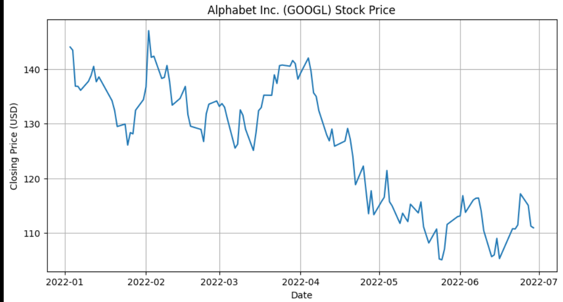

Result:
The experiment was executed successfully.
The expected result was obtained.

EXPERIMENT 5: Bar Plot of Trading Volume
Aim:
To perform the given experiment using Python as per the lab manual.
To understand the concept and obtain the required output.
Algorithm:
1. Start the program.
2. Import the required libraries.
3. Load or define the given input data.
4. Apply the required operation as per the experiment.
5. Process the data using suitable functions.
6. Verify the intermediate output if required.
7. Display the final output.
8. Stop the program.
Output & Code:
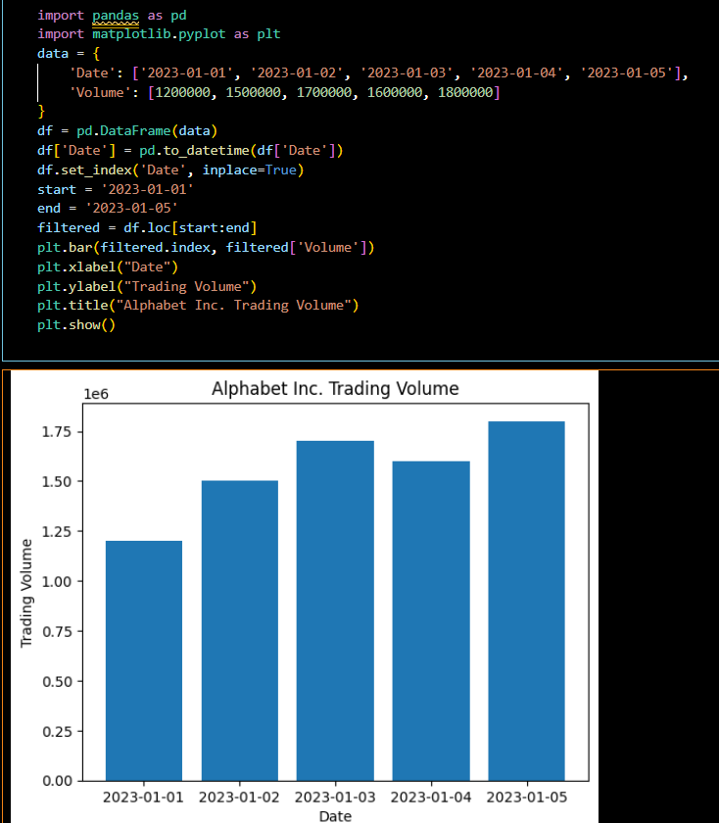
Result:
The experiment was executed successfully.
The expected result was obtained.

EXPERIMENT 6: Scatter Plot of Price vs Volume
Aim:
To perform the given experiment using Python as per the lab manual.
To understand the concept and obtain the required output.
Algorithm:
1. Start the program.
2. Import the required libraries.
3. Load or define the given input data.
4. Apply the required operation as per the experiment.
5. Process the data using suitable functions.
6. Verify the intermediate output if required.
7. Display the final output.
8. Stop the program.
Output & Code:
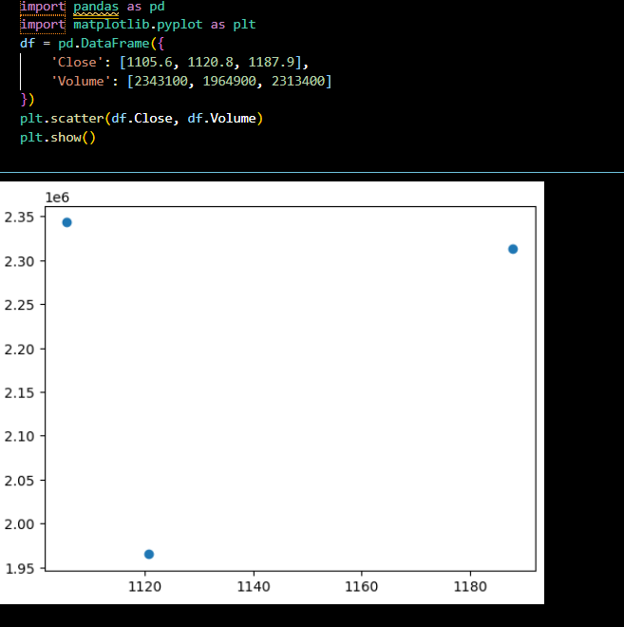
Result:
The experiment was executed successfully.
The expected result was obtained.

EXPERIMENT 7: Pivot Table – Max & Min Sales
Aim:
To perform the given experiment using Python as per the lab manual.
To understand the concept and obtain the required output.
Algorithm:
1. Start the program.
2. Import the required libraries.
3. Load or define the given input data.
4. Apply the required operation as per the experiment.
5. Process the data using suitable functions.
6. Verify the intermediate output if required.
7. Display the final output.
8. Stop the program.
Output & Code
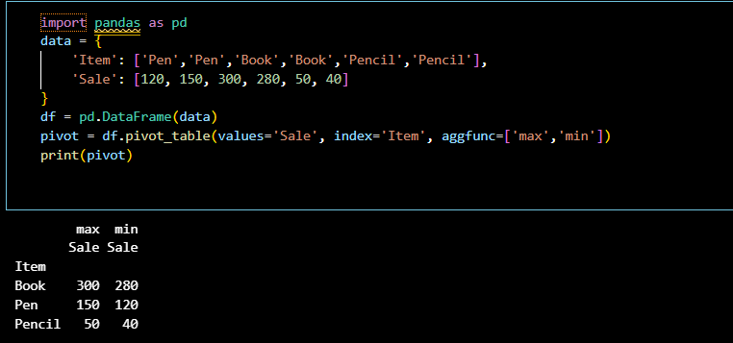
Result:
The experiment was executed successfully.
The expected result was obtained.

EXPERIMENT 8: Pivot Table – Units Sold
Aim:
To perform the given experiment using Python as per the lab manual.
To understand the concept and obtain the required output.
Algorithm:
1. Start the program.
2. Import the required libraries.
3. Load or define the given input data.
4. Apply the required operation as per the experiment.
5. Process the data using suitable functions.
6. Verify the intermediate output if required.
7. Display the final output.
8. Stop the program.
Output & Code
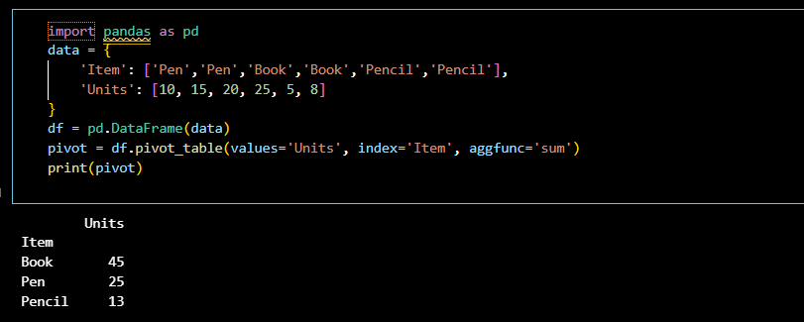
Result:
The experiment was executed successfully.
The expected result was obtained.

EXPERIMENT 9: Pivot Table – Total Sales
Aim:
To perform the given experiment using Python as per the lab manual.
To understand the concept and obtain the required output.
Algorithm:
1. Start the program.
2. Import the required libraries.
3. Load or define the given input data.
4. Apply the required operation as per the experiment.
5. Process the data using suitable functions.
6. Verify the intermediate output if required.
7. Display the final output.
8. Stop the program.
Output & Code
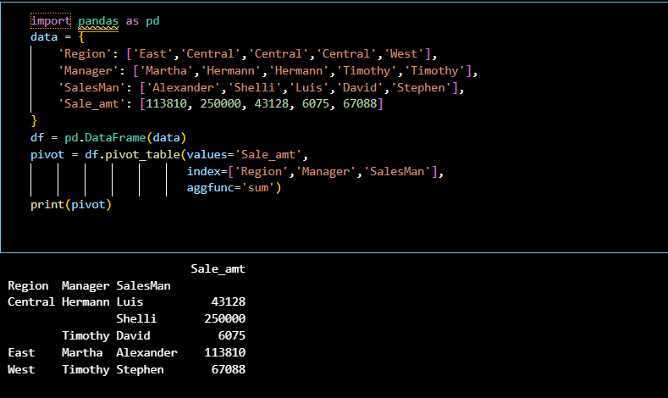
Result:
The experiment was executed successfully.
The expected result was obtained.

EXPERIMENT 10: Highlight Positive & Negative Values
Aim:
To perform the given experiment using Python as per the lab manual.
To understand the concept and obtain the required output.
Algorithm:
1. Start the program.
2. Import the required libraries.
3. Load or define the given input data.
4. Apply the required operation as per the experiment.
5. Process the data using suitable functions.
6. Verify the intermediate output if required.
7. Display the final output.
8. Stop the program.
Output & Code
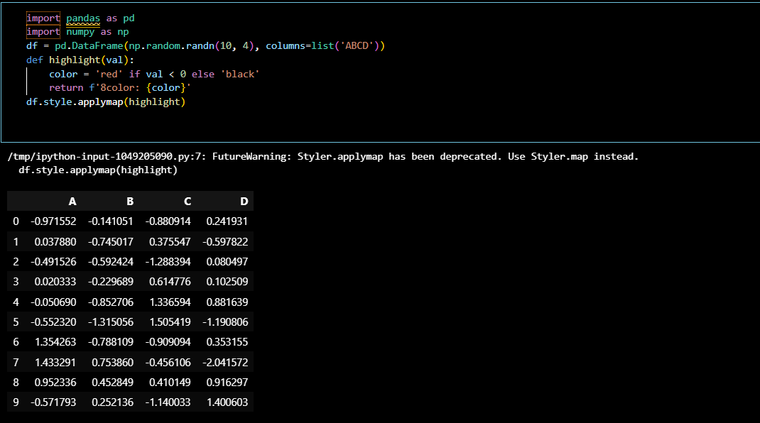
Result:
The experiment was executed successfully.
The expected result was obtained.

EXPERIMENT 11: Highlight Missing Values
Aim:
To perform the given experiment using Python as per the lab manual.
To understand the concept and obtain the required output.
Algorithm:
1. Start the program.
2. Import the required libraries.
3. Load or define the given input data.
4. Apply the required operation as per the experiment.
5. Process the data using suitable functions.
6. Verify the intermediate output if required.
7. Display the final output.
8. Stop the program.
Output & Code:
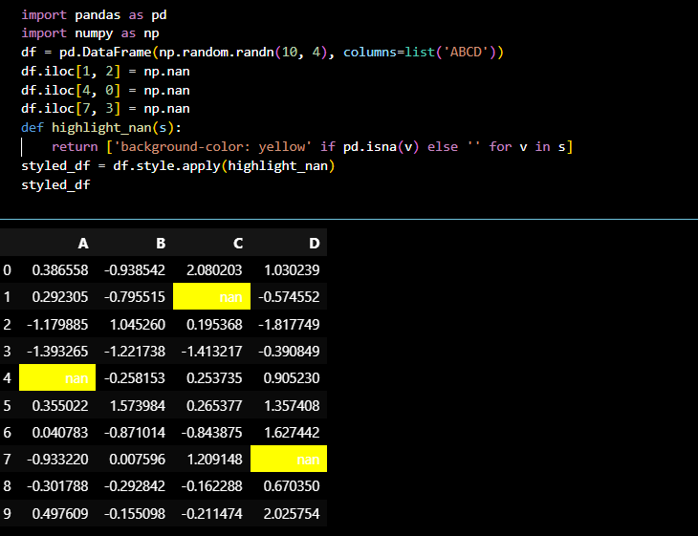
Result:
The experiment was executed successfully.
The expected result was obtained.

EXPERIMENT 12: DataFrame Styling
Aim:
To perform the given experiment using Python as per the lab manual.
To understand the concept and obtain the required output.
Algorithm:
1. Start the program.
2. Import the required libraries.
3. Load or define the given input data.
4. Apply the required operation as per the experiment.
5. Process the data using suitable functions.
6. Verify the intermediate output if required.
7. Display the final output.
8. Stop the program.
Output & Code:
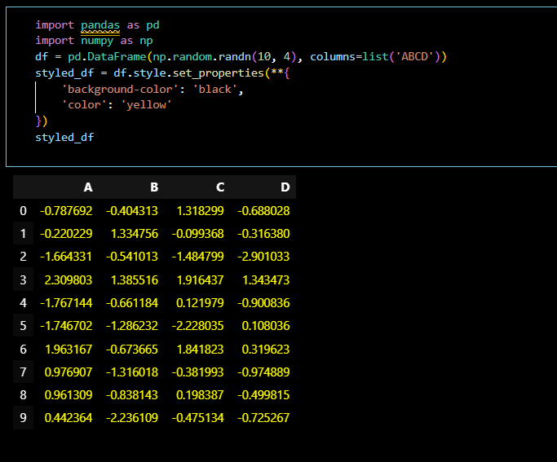
Result:
The experiment was executed successfully.
The expected result was obtained.
EXPERIMENT 13: Detect Missing Values
Aim:
To perform the given experiment using Python as per the lab manual.
To understand the concept and obtain the required output.
Algorithm:
1. Start the program.
2. Import the required libraries.
3. Load or define the given input data.
4. Apply the required operation as per the experiment.
5. Process the data using suitable functions.
6. Verify the intermediate output if required.
7. Display the final output.
8. Stop the program.
Output & Code
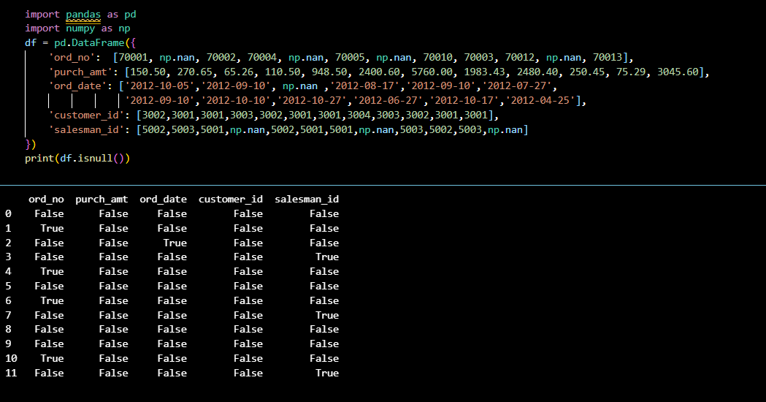
Result:
The experiment was executed successfully.
The expected result was obtained.
EXPERIMENT 14: Replace Missing Values
Aim:
To perform the given experiment using Python as per the lab manual.
To understand the concept and obtain the required output.
Algorithm:
1. Start the program.
2. Import the required libraries.
3. Load or define the given input data.
4. Apply the required operation as per the experiment.
5. Process the data using suitable functions.
6. Verify the intermediate output if required.
7. Display the final output.
8. Stop the program.
Output & Code
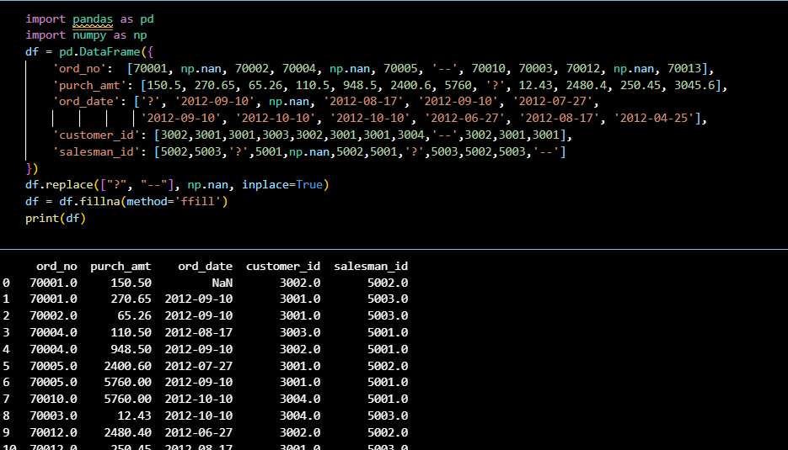
Result:
The experiment was executed successfully.
The expected result was obtained.
EXPERIMENT 15: Rows with Two Missing Values
Aim:
To perform the given experiment using Python as per the lab manual.
To understand the concept and obtain the required output.
Algorithm:
1. Start the program.
2. Import the required libraries.
3. Load or define the given input data.
4. Apply the required operation as per the experiment.
5. Process the data using suitable functions.
6. Verify the intermediate output if required.
7. Display the final output.
8. Stop the program.
Output & Code
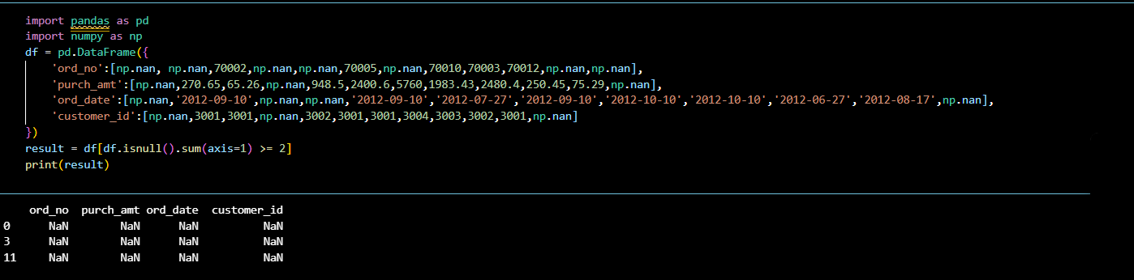
Result:
The experiment was executed successfully.
The expected result was obtained.

EXPERIMENT 16: Group Data by School Code
Aim:
To perform the given experiment using Python as per the lab manual.
To understand the concept and obtain the required output.
Algorithm:
1. Start the program.
2. Import the required libraries.
3. Load or define the given input data.
4. Apply the required operation as per the experiment.
5. Process the data using suitable functions.
6. Verify the intermediate output if required.
7. Display the final output.
8. Stop the program.
Output & Code:
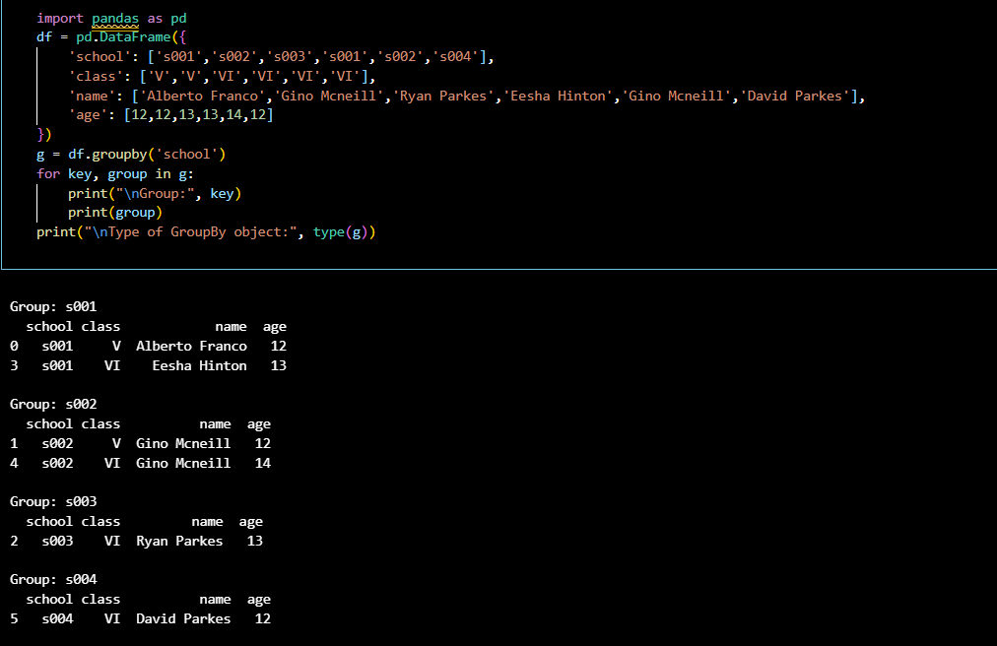

Result:
The experiment was executed successfully.
The expected result was obtained.
EXPERIMENT 17: Aggregate Age by School
Aim:
To perform the given experiment using Python as per the lab manual.
To understand the concept and obtain the required output.
Algorithm:
1. Start the program.
2. Import the required libraries.
3. Load or define the given input data.
4. Apply the required operation as per the experiment.
5. Process the data using suitable functions.
6. Verify the intermediate output if required.
7. Display the final output.
8. Stop the program.
Output & Code:
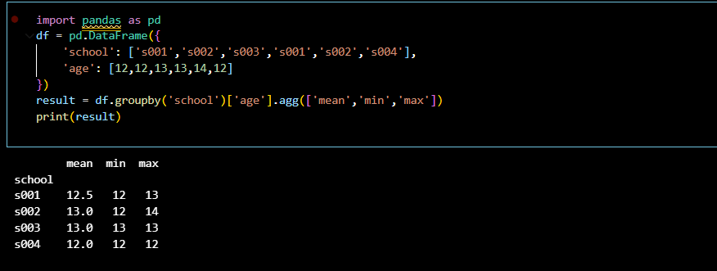

Result:
The experiment was executed successfully.
The expected result was obtained.

EXPERIMENT 18: Group by School and Class
Aim:
To perform the given experiment using Python as per the lab manual.
To understand the concept and obtain the required output.
Algorithm:
1. Start the program.
2. Import the required libraries.
3. Load or define the given input data.
4. Apply the required operation as per the experiment.
5. Process the data using suitable functions.
6. Verify the intermediate output if required.
7. Display the final output.
8. Stop the program.
Output & Code
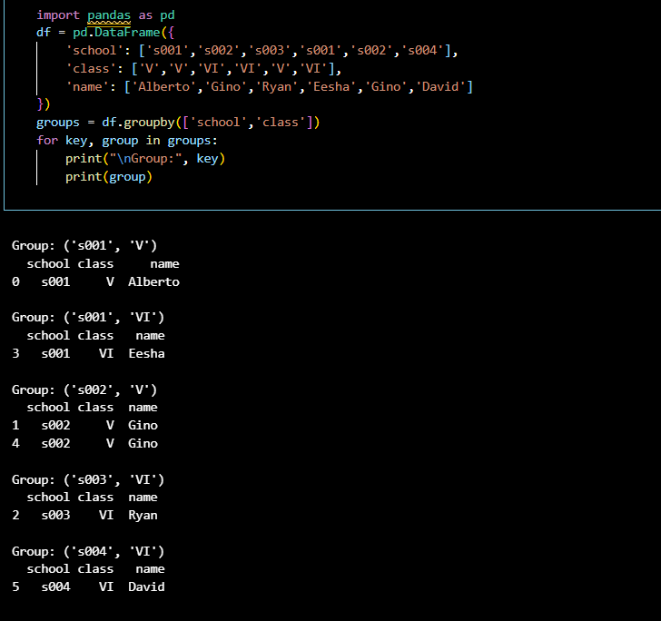
Result:
The experiment was executed successfully.
The expected result was obtained.
EXPERIMENT 19: Dataset Shape and Columns
Aim:
To perform the given experiment using Python as per the lab manual.
To understand the concept and obtain the required output.
Algorithm:
1. Start the program.
2. Import the required libraries.
3. Load or define the given input data.
4. Apply the required operation as per the experiment.
5. Process the data using suitable functions.
6. Verify the intermediate output if required.
7. Display the final output.
8. Stop the program.
Output & Code
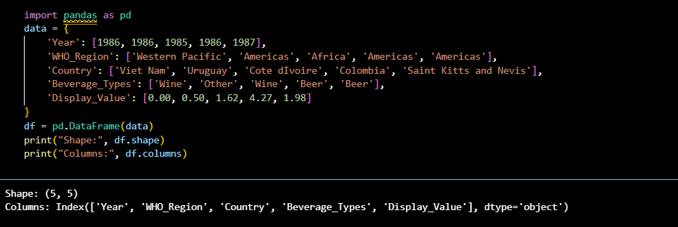
Result:
The experiment was executed successfully.
The expected result was obtained.

EXPERIMENT 20: Substring Index in Column
Aim:
To perform the given experiment using Python as per the lab manual.
To understand the concept and obtain the required output.
Algorithm:
1. Start the program.
2. Import the required libraries.
3. Load or define the given input data.
4. Apply the required operation as per the experiment.
5. Process the data using suitable functions.
6. Verify the intermediate output if required.
7. Display the final output.
8. Stop the program.
Output & code
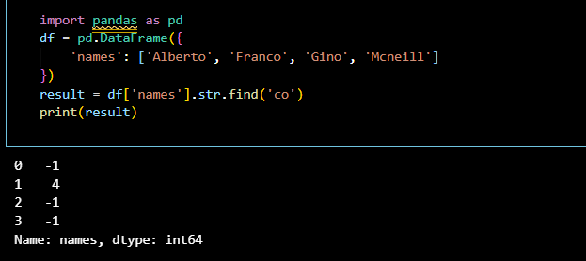
Result:
The experiment was executed successfully.
The expected result was obtained.

EXPERIMENT 21: Swap Case in Column
Aim:
To perform the given experiment using Python as per the lab manual.
To understand the concept and obtain the required output.
Algorithm:
1. Start the program.
2. Import the required libraries.
3. Load or define the given input data.
4. Apply the required operation as per the experiment.
5. Process the data using suitable functions.
6. Verify the intermediate output if required.
7. Display the final output.
8. Stop the program.
Output & Code
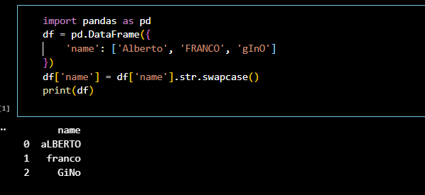
Result:
The experiment was executed successfully.
The expected result was obtained.

EXPERIMENT 22: Simple Line Graph
Aim:
To perform the given experiment using Python as per the lab manual.
To understand the concept and obtain the required output.
Algorithm:
1. Start the program.
2. Import the required libraries.
3. Load or define the given input data.
4. Apply the required operation as per the experiment.
5. Process the data using suitable functions.
6. Verify the intermediate output if required.
7. Display the final output.
8. Stop the program.
Output & Data
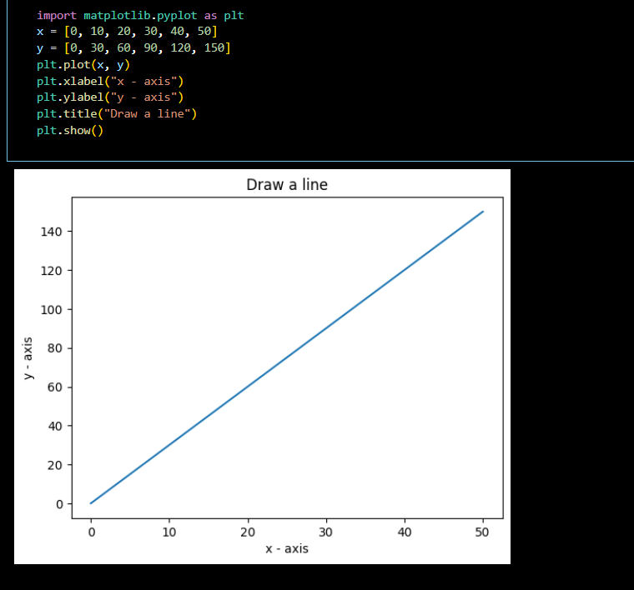
Result:
The experiment was executed successfully.
The expected result was obtained.

EXPERIMENT 23: Line Graph using File Data
Aim:
To perform the given experiment using Python as per the lab manual.
To understand the concept and obtain the required output.
Algorithm:
1. Start the program.
2. Import the required libraries.
3. Load or define the given input data.
4. Apply the required operation as per the experiment.
5. Process the data using suitable functions.
6. Verify the intermediate output if required.
7. Display the final output.
8. Stop the program.
Output & Code
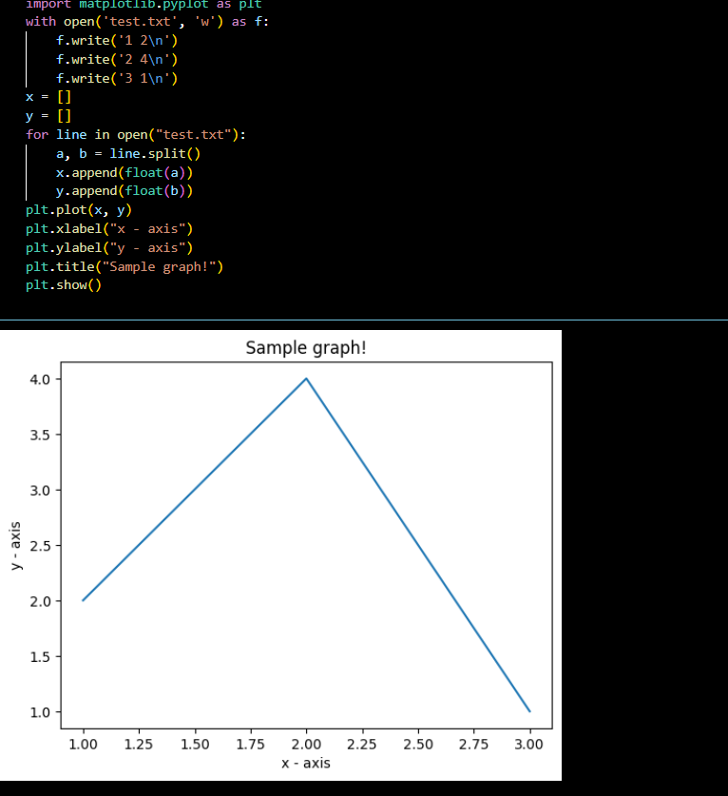
Result:
The experiment was executed successfully.
The expected result was obtained.

EXPERIMENT 24: Financial Data Plot
Aim:
To perform the given experiment using Python as per the lab manual.
To understand the concept and obtain the required output.
Algorithm:
1. Start the program.
2. Import the required libraries.
3. Load or define the given input data.
4. Apply the required operation as per the experiment.
5. Process the data using suitable functions.
6. Verify the intermediate output if required.
7. Display the final output.
8. Stop the program.
Output & code
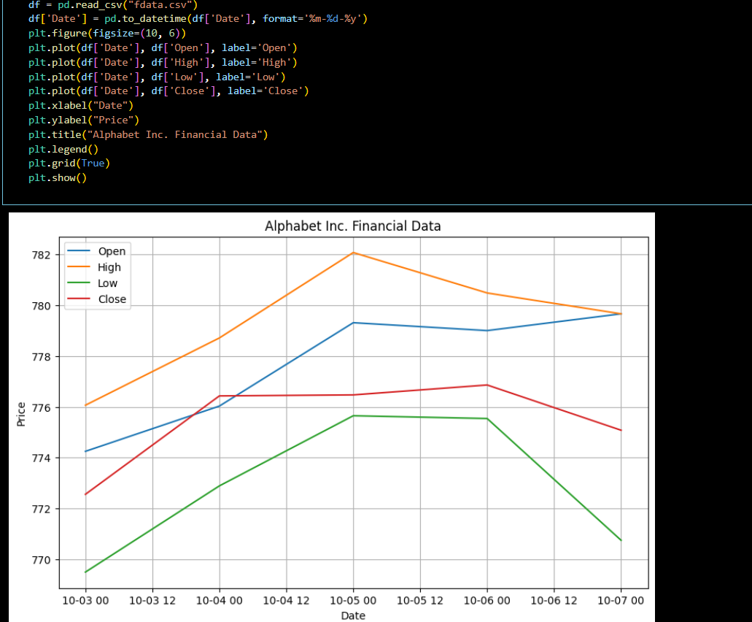
Result:
The experiment was executed successfully.
The expected result was obtained.

EXPERIMENT 25: Multiple Line Plot
Aim:
To perform the given experiment using Python as per the lab manual.
To understand the concept and obtain the required output.
Algorithm:
1. Start the program.
2. Import the required libraries.
3. Load or define the given input data.
4. Apply the required operation as per the experiment.
5. Process the data using suitable functions.
6. Verify the intermediate output if required.
7. Display the final output.
8. Stop the program.
Output & Code
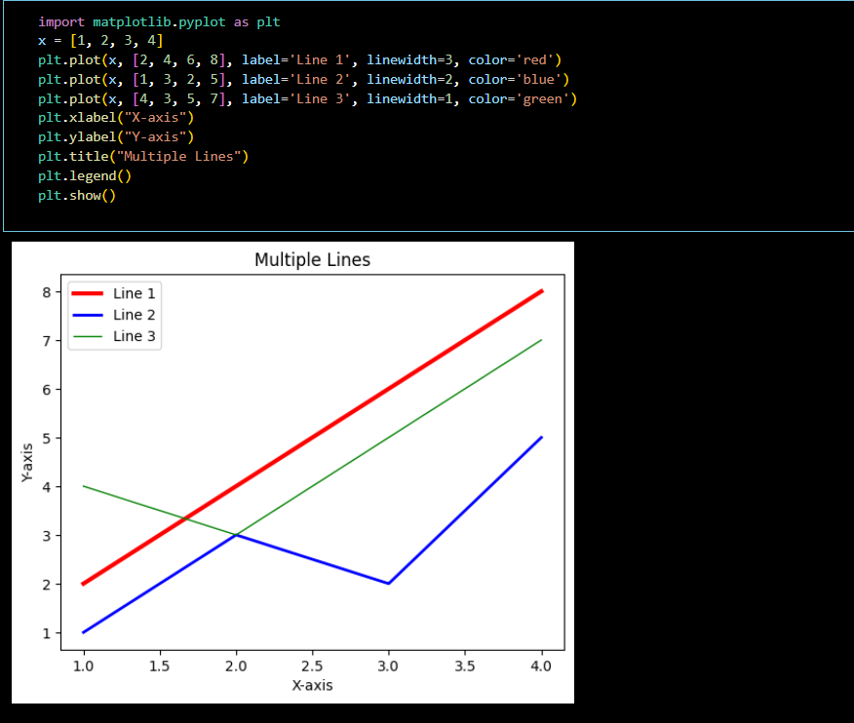
Result:
The experiment was executed successfully.
The expected result was obtained.

EXPERIMENT 26: Multiple Plots
Aim:
To perform the given experiment using Python as per the lab manual.
To understand the concept and obtain the required output.
Algorithm:
1. Start the program.
2. Import the required libraries.
3. Load or define the given input data.
4. Apply the required operation as per the experiment.
5. Process the data using suitable functions.
6. Verify the intermediate output if required.
7. Display the final output.
8. Stop the program.
Output & Code
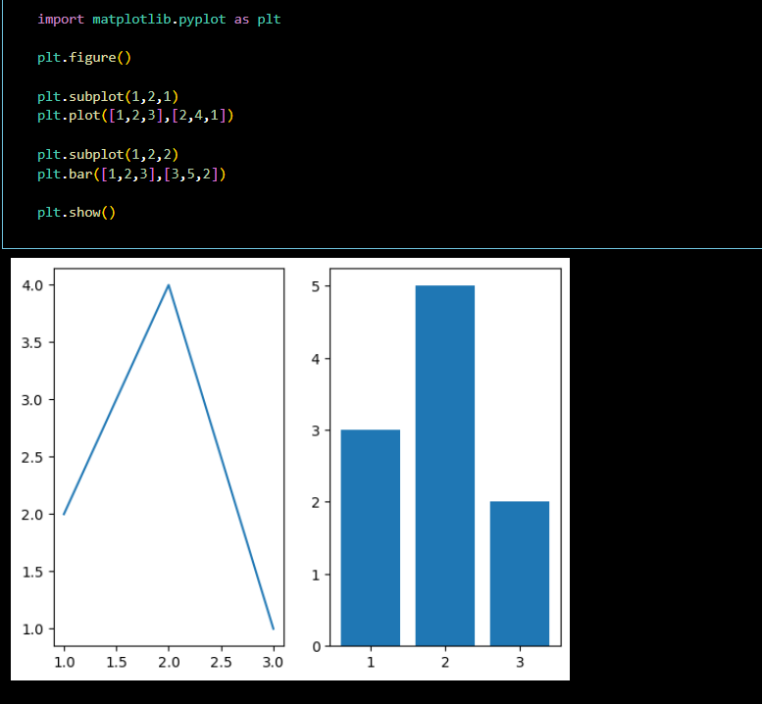
Result:
The experiment was executed successfully.
The expected result was obtained.
EXPERIMENT 27: Bar Chart – Language Popularity
Aim:
To perform the given experiment using Python as per the lab manual.
To understand the concept and obtain the required output.
Algorithm:
1. Start the program.
2. Import the required libraries.
3. Load or define the given input data.
4. Apply the required operation as per the experiment.
5. Process the data using suitable functions.
6. Verify the intermediate output if required.
7. Display the final output.
8. Stop the program.
Output & Code
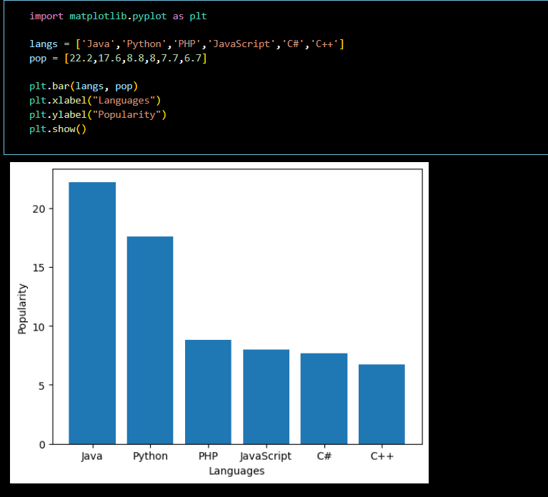
Result:
The experiment was executed successfully.
The expected result was obtained.

EXPERIMENT 28: Horizontal Bar Chart
Aim:
To perform the given experiment using Python as per the lab manual.
To understand the concept and obtain the required output.
Algorithm:
1. Start the program.
2. Import the required libraries.
3. Load or define the given input data.
4. Apply the required operation as per the experiment.
5. Process the data using suitable functions.
6. Verify the intermediate output if required.
7. Display the final output.
8. Stop the program.
Output& Code
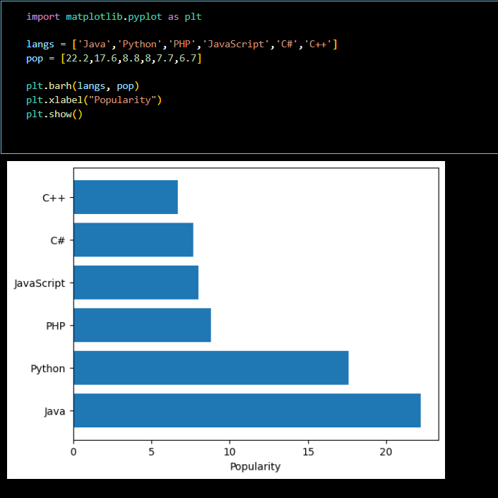
Result:
The experiment was executed successfully.
The expected result was obtained.
EXPERIMENT 29: Colored Bar Chart
Aim:
To perform the given experiment using Python as per the lab manual.
To understand the concept and obtain the required output.
Algorithm:
1. Start the program.
2. Import the required libraries.
3. Load or define the given input data.
4. Apply the required operation as per the experiment.
5. Process the data using suitable functions.
6. Verify the intermediate output if required.
7. Display the final output.
8. Stop the program.
Output & Code:
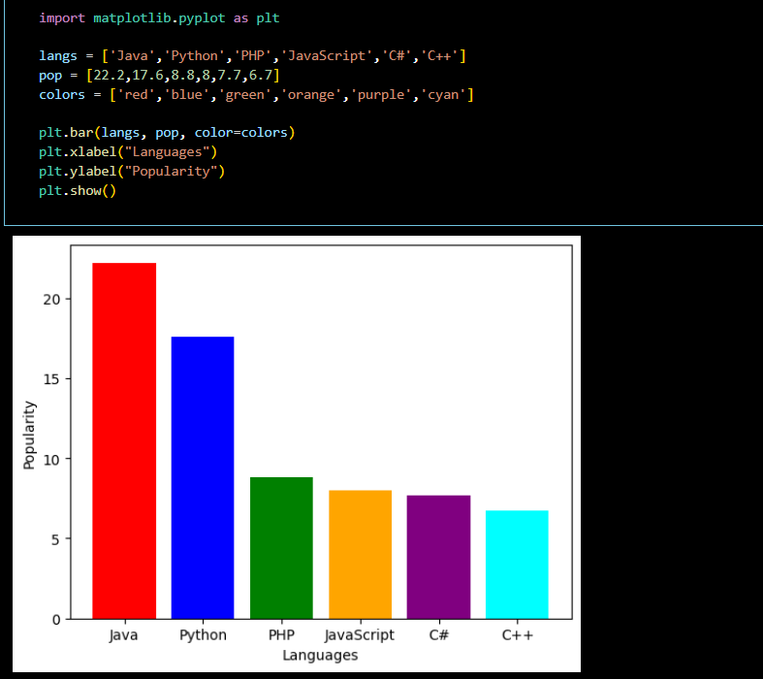
Result:
The experiment was executed successfully.
The expected result was obtained.

EXPERIMENT 30: Men vs Women Scores
Aim:
To perform the given experiment using Python as per the lab manual.
To understand the concept and obtain the required output.
Algorithm:
1. Start the program.
2. Import the required libraries.
3. Load or define the given input data.
4. Apply the required operation as per the experiment.
5. Process the data using suitable functions.
6. Verify the intermediate output if required.
7. Display the final output.
8. Stop the program.
Output & Code :
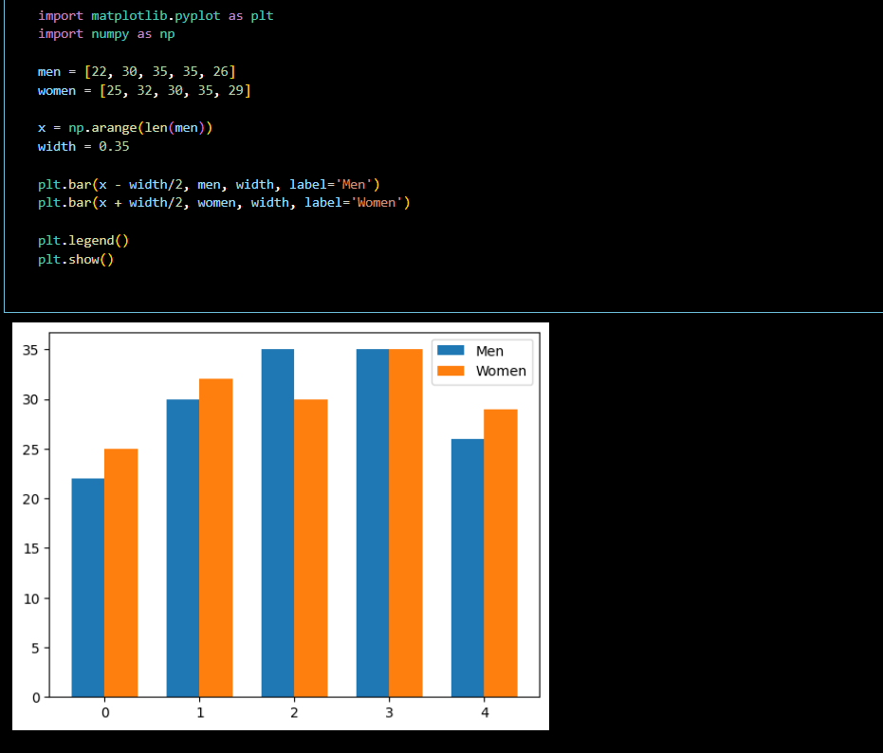
Result:
The experiment was executed successfully.
The expected result was obtained.
EXPERIMENT 31: Stacked Bar Plot with Error Bars
Aim:
To perform the given experiment using Python as per the lab manual.
To understand the concept and obtain the required output.
Algorithm:
1. Start the program.
2. Import the required libraries.
3. Load or define the given input data.
4. Apply the required operation as per the experiment.
5. Process the data using suitable functions.
6. Verify the intermediate output if required.
7. Display the final output.
8. Stop the program.
Output & Code
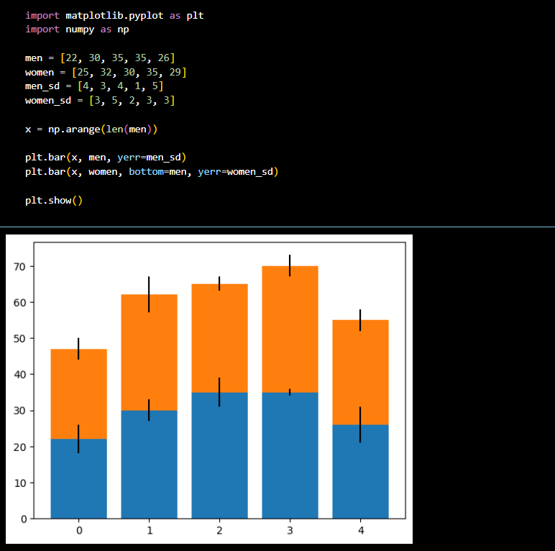
Result:
The experiment was executed successfully.
The expected result was obtained.

EXPERIMENT 32: Random Scatter Plot
Aim:
To perform the given experiment using Python as per the lab manual.
To understand the concept and obtain the required output.
Algorithm:
1. Start the program.
2. Import the required libraries.
3. Load or define the given input data.
4. Apply the required operation as per the experiment.
5. Process the data using suitable functions.
6. Verify the intermediate output if required.
7. Display the final output.
8. Stop the program.
Output & Code
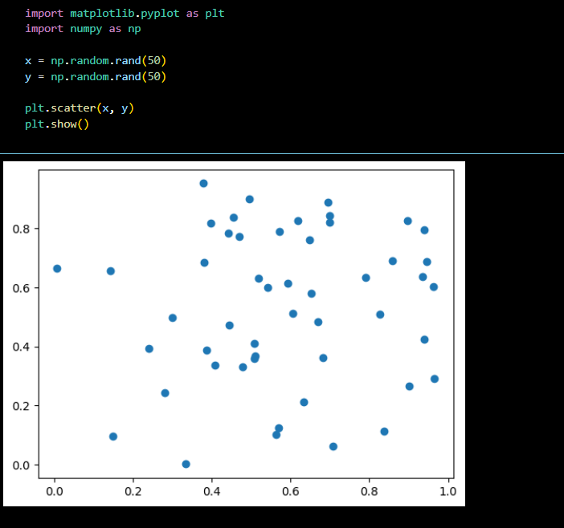
Result:
The experiment was executed successfully.
The expected result was obtained.
EXPERIMENT 33: Empty Circle Scatter Plot
Aim:
To perform the given experiment using Python as per the lab manual.
To understand the concept and obtain the required output.
Algorithm:
1. Start the program.
2. Import the required libraries.
3. Load or define the given input data.
4. Apply the required operation as per the experiment.
5. Process the data using suitable functions.
6. Verify the intermediate output if required.
7. Display the final output.
8. Stop the program.
Output& Code
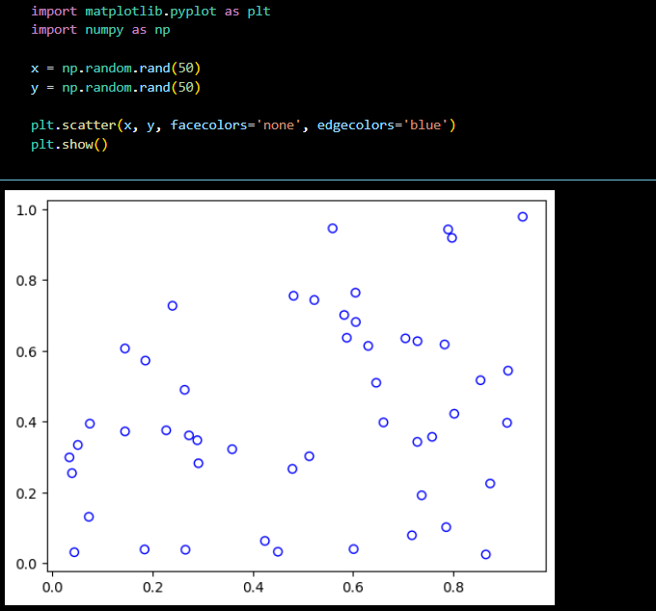
Result:
The experiment was executed successfully.
The expected result was obtained.
EXPERIMENT 34: Variable Size Scatter Plot
Aim:
To perform the given experiment using Python as per the lab manual.
To understand the concept and obtain the required output.
Algorithm:
1. Start the program.
2. Import the required libraries.
3. Load or define the given input data.
4. Apply the required operation as per the experiment.
5. Process the data using suitable functions.
6. Verify the intermediate output if required.
7. Display the final output.
8. Stop the program.
Output & Code:
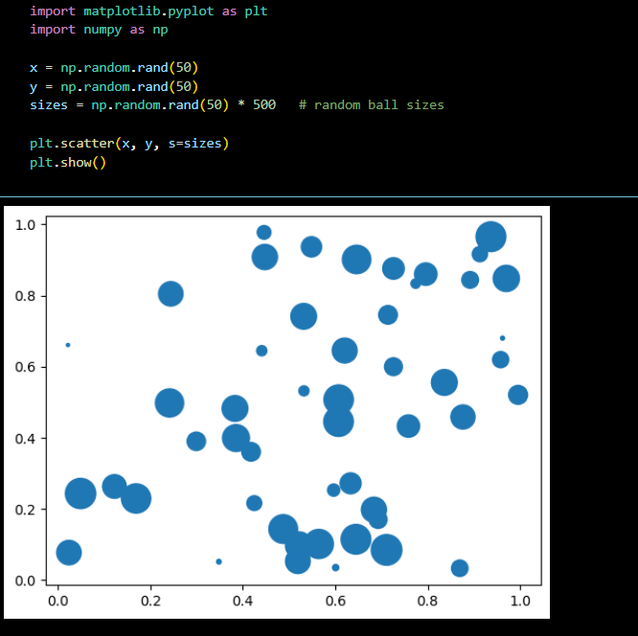
Result:
The experiment was executed successfully.
The expected result was obtained.
EXPERIMENT 35: Math vs Science Marks
Aim:
To perform the given experiment using Python as per the lab manual.
To understand the concept and obtain the required output.
Algorithm:
1. Start the program.
2. Import the required libraries.
3. Load or define the given input data.
4. Apply the required operation as per the experiment.
5. Process the data using suitable functions.
6. Verify the intermediate output if required.
7. Display the final output.
8. Stop the program.
Output & Code
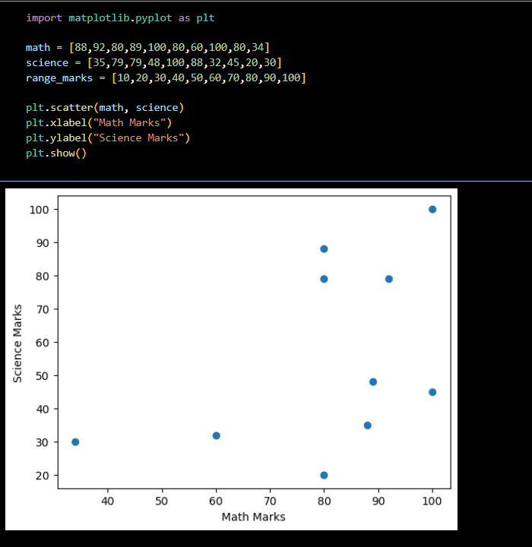
Result:
The experiment was executed successfully.
The expected result was obtained.
EXPERIMENT 36: Height vs Weight Comparison
Aim:
To perform the given experiment using Python as per the lab manual.
To understand the concept and obtain the required output.
Algorithm:
1. Start the program.
2. Import the required libraries.
3. Load or define the given input data.
4. Apply the required operation as per the experiment.
5. Process the data using suitable functions.
6. Verify the intermediate output if required.
7. Display the final output.
8. Stop the program.
Output & Code
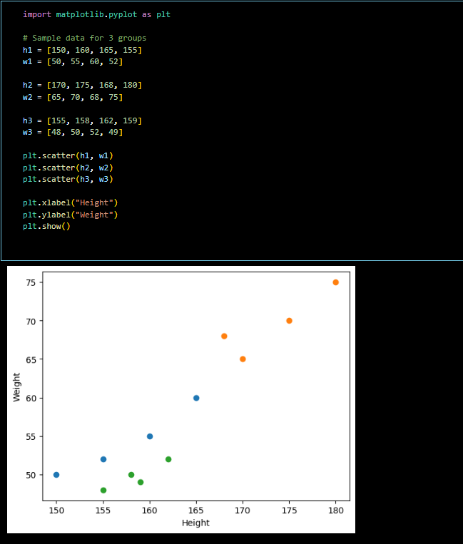
Result:
The experiment was executed successfully.
The expected result was obtained.
EXPERIMENT 37: DataFrame from Dictionary
Aim:
To perform the given experiment using Python as per the lab manual.
To understand the concept and obtain the required output.
Algorithm:
1. Start the program.
2. Import the required libraries.
3. Load or define the given input data.
4. Apply the required operation as per the experiment.
5. Process the data using suitable functions.
6. Verify the intermediate output if required.
7. Display the final output.
8. Stop the program.
Output & Code
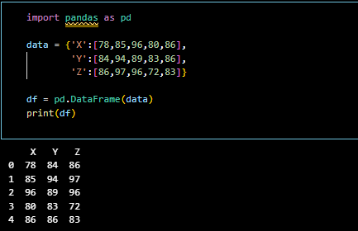
Result:
The experiment was executed successfully.
The expected result was obtained.
EXPERIMENT 38: DataFrame with Index
Aim:
To perform the given experiment using Python as per the lab manual.
To understand the concept and obtain the required output.
Algorithm:
1. Start the program.
2. Import the required libraries.
3. Load or define the given input data.
4. Apply the required operation as per the experiment.
5. Process the data using suitable functions.
6. Verify the intermediate output if required.
7. Display the final output.
8. Stop the program.
Output & Code
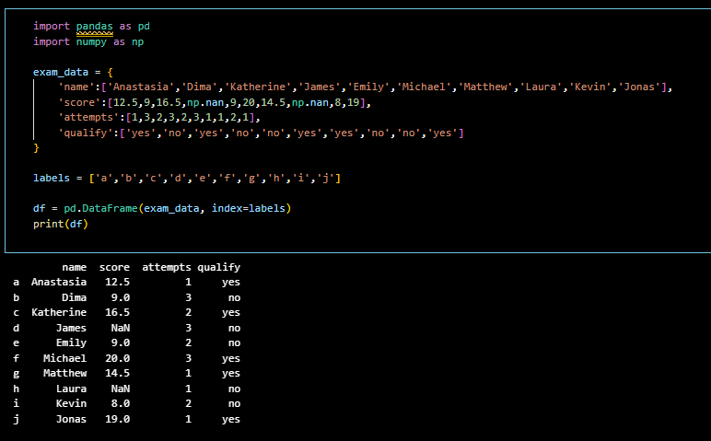
Result:
The experiment was executed successfully.
The expected result was obtained.

EXPERIMENT 39: First Three Rows
Aim:
To perform the given experiment using Python as per the lab manual.
To understand the concept and obtain the required output.
Algorithm:
1. Start the program.
2. Import the required libraries.
3. Load or define the given input data.
4. Apply the required operation as per the experiment.
5. Process the data using suitable functions.
6. Verify the intermediate output if required.
7. Display the final output.
8. Stop the program.
Output & Code
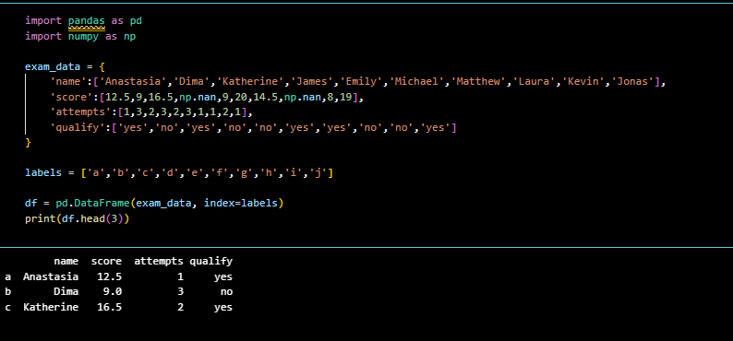
Result:
The experiment was executed successfully.
The expected result was obtained.

EXPERIMENT 40: Select Columns from DataFrame
Aim:
To perform the given experiment using Python as per the lab manual.
To understand the concept and obtain the required output.
Algorithm:
1. Start the program.
2. Import the required libraries.
3. Load or define the given input data.
4. Apply the required operation as per the experiment.
5. Process the data using suitable functions.
6. Verify the intermediate output if required.
7. Display the final output.
8. Stop the program.
output & code
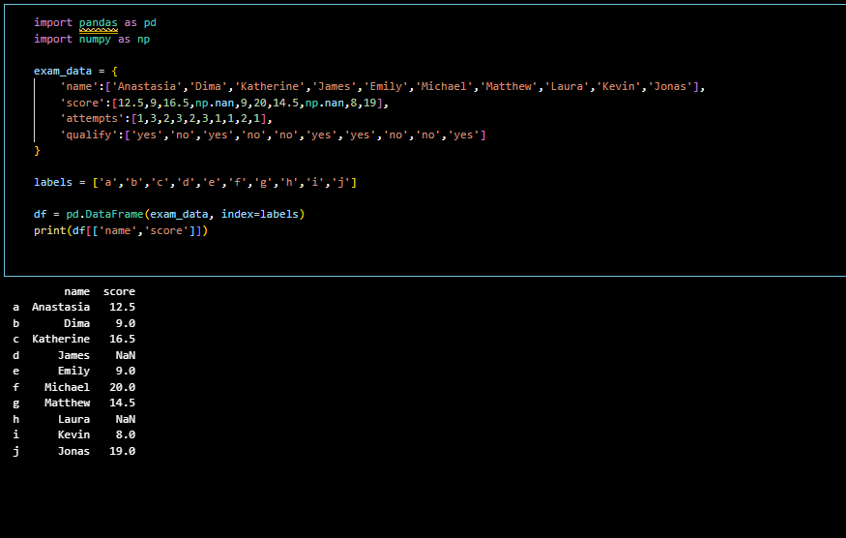
Result:
The experiment was executed successfully.
The expected result was obtained.

